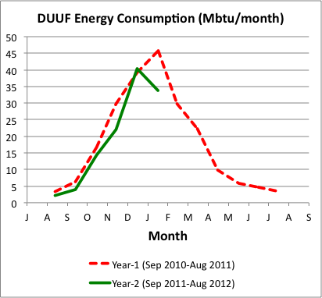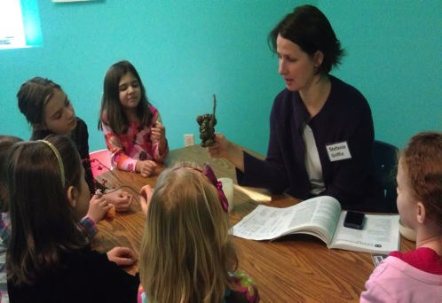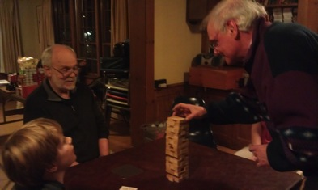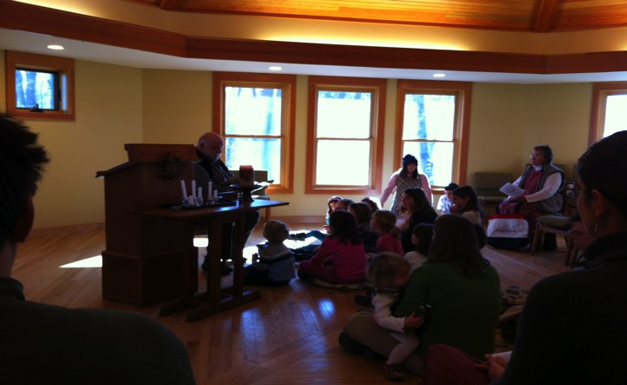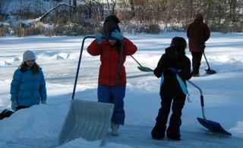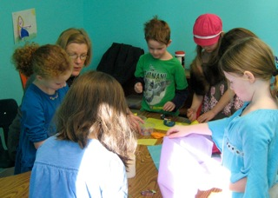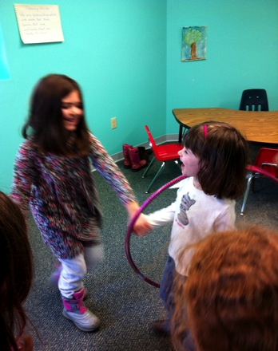

### DUUF: Energy Efficient

The chart shows monthly total energy consumption at our Fellowship house since completion of its expansion and renovation. Consumption includes both natural gas and electricity. The total for year-1, 217 Mbtu, matched that of our average annual consumption over the five-year period prior to renovation. That’s impressive given that we are now operating in a 50% larger building. So far in year-2 we have used less energy than in year-1, but there are still a few winter months ahead of us. Insulation of the remaining, hard to reach heat-leaky, areas of our roof would help reduce our consumption significantly. That work is on the Fellowship’s wish list, but the cost is delaying action. We welcome any suggestions or help toward the goal of further reductions in our energy use.

John Macri

Green Sanctuary Committee

Speaker: Larry Brickner-Wood

Topic: TBA

Speakers: Carmen Buford-Paige, Thomas Pistole,

Dale Rice

Topic: The Power of Music

Speaker: Mary Edes

Topic: So…What’s Your Theology?

Speaker: Beata Umugwangwali

Topic:Forgiveness

3/25/12

3/18/12

3/4/12

3/11/12

#### Upcoming Services in February (at 10 am)

Newsletter of the Durham Unitarian Universalists Fellowship

HEED

the

MARCH Issue 2012

**Needs for Seacoast Family Promise**

Alyia, a new child at Seacoast Family Promise, has virtually no clothing including underwear, and socks. **She needs clothes before she returns to school next week.**

Size 8 Shirts and size 7/8 pants

Size 7/8 underwear

Shoe/sneaker size 21/2 or 3

Jacket size 8

Pati has purchased some immediate needs clothing from SFP resources here but would appreciate any help that you can lend. Also, a new baby girl will be arriving by C-section on March 1.  If you have access to any infant clothing please consider donating them to this little one.

I will be out of town until February 29th, so please take any donations to the SFP day center at the Stratham Community Church.  It is located down the driveway behind the church on the ground floor.

Thanks,

Betty Crepeau

HEeD

March 2012

DUUF GAME NIGHT

. . just one more ! ! !

March 2012

HEeD

# Sign in please: a message from the DUUF President

Communications is the watch word around the DUUF these days – as in watch as the Website continues to regenerate from the technical troubles of last Fall. Watch as you enter the sanctuary: There are orders of service and upcoming events sitting right there on a stool, waiting for you to pick them up and read them. Rumor has it, there might be a nice new table for these things soon. And watch our sign out front. We’ll be projecting our philosophies out to the general Madbury Road traffic, thanks to some help from the UUA’s Wayside Pulpit program. They’ve collected lists of great statements that can inspire people and encourage deep thinking. They may even bring some more feet up the walkway on Sunday mornings.

The UUA Website offers plans to build your own box to display the quotations, but we can work it out with our already-existing sign. It’s actually on of the items on the “wish list” that we came up with at last year’s Annual Business Meeting, and it should end up costing us nothing.

John Macri already got us started with a quote from Dr. Martin Luther King Jr., inspired by a Sunday service in January. John used the old “analog” method for using the sign. This is painstaking to create and easy to scramble by bumping the sign and knocking the letters off their hangers. The new “digital” process should be sturdier, if less elegant.

So all that remains is to pick out the ideas we wish to present to the traffic. I must admit, this is proving to be more difficult than I had expected. What exactly is it that we’d like to say? How can we reflect what goes on inside our building?

It’s too much of a job for one person, even with the UUA doing most of the legwork. Below is this year’s list of quotations. Expect that we’ll change the sign every month or so. That will give us three, maybe four different messages to put up before the end of the year (then we’ll have to figure out if we want to continue this over the summer). If you would like to have a say in the matter, email me at [bobpavlik@comcast.net](mailto:bobpavlik@comcast.net) and let me know your three favorite quotations from the list. We’ll display the three top vote-getters – that is the three that most people send to me, no weight for first, second or third choice.

In the meantime, I will make an executive decision and pick the first message – which is easy as it is the very first one on the list. Look for it this week or possibly early next week.

1. [What is it you plan to do with your one wild and precious life](http://img.uua.org/wayside/series8/Number01.pdf)?  
   —Mary Oliver *
2. [*There are hundreds of ways to kneel and kiss the ground*](http://img.uua.org/wayside/series8/Number02.pdf).  
   —Jelaluddin Rumi
3. [*Be ashamed to die until you have won some victory for humanity*](http://img.uua.org/wayside/series8/Number03.pdf).  
   —Horace Mann
4. [*Be not afraid of growing slowly. Be afraid only of standing still*](http://img.uua.org/wayside/series8/Number04.pdf).  
   —Chinese Proverb
5. [*Pray for the dead. Fight like hell for the living*](http://img.uua.org/wayside/series8/Number05.pdf).  
   —Mother Jones
6. [*Our deepest fear is that we are powerful beyond measure*](http://img.uua.org/wayside/series8/Number06.pdf).  
   —Marianne Williamson
7. [*Nature never did betray the heart that loved her*](http://img.uua.org/wayside/series8/Number07.pdf).  
   —William Wordsworth
8. [*Love is a growing up*](http://img.uua.org/wayside/series8/Number08.pdf).  
   —James Baldwin
9. [*Because I have been athirst, I will dig a well that others may drink*](http://img.uua.org/wayside/series8/Number09.pdf).  
   —Arabian proverb
10. [*Forgiveness is the final form of love*](http://img.uua.org/wayside/series8/Number10.pdf).  
    —Reinhold Niebuhr
11. [*Our growing thought makes growing revelation*](http://img.uua.org/wayside/series8/Number11.pdf).   
    —George Eliot
12. [*Love is a faith, and one faith leads to another*](http://img.uua.org/wayside/series8/Number12.pdf).  
    —Henri Frederic Amiel
13. [*The universe will reward you for taking risks on its behalf*](http://img.uua.org/wayside/series8/Number13.pdf).  
    —Shakti Gawain
14. [*An idea is salvation by imagination*](http://img.uua.org/wayside/series8/Number14.pdf).  
    —Frank Lloyd Wright
15. [*The only joy in the world is to begin*](http://img.uua.org/wayside/series8/Number15.pdf).  
    —Cesar Pavese
16. [*Time does not change us. It just unfolds us*](http://img.uua.org/wayside/series8/Number16.pdf).  
    —Max Frisch
17. [*As soon as you trust yourself, you will know how to live*](http://img.uua.org/wayside/series8/Number17.pdf).  
    —Johann Wolfgang von Goethe
18. [*We are all geniuses when we dream*](http://img.uua.org/wayside/series8/Number18.pdf).  
    —E. M. Cioran
19. [*Live out of your imagination, not your history*](http://img.uua.org/wayside/series8/Number19.pdf).  
    —Stephen R. Covey
20. [*Injustice anywhere is a threat to justice everywhere*](http://img.uua.org/wayside/series8/Number20.pdf).  
    —Martin Luther King
21. [*The greatest gift you can give another is the purity of your attention*](http://img.uua.org/wayside/series8/Number21.pdf).  
    —Richard Moss
22. [*If I can't dance, it's not my revolution*](http://img.uua.org/wayside/series8/Number22.pdf).  
    —Emma Goldman
23. [*It is courage the world needs, not infallibility*](http://img.uua.org/wayside/series8/Number23.pdf).  
    —Wilfred Grenfell
24. [*Ambitious people climb, but faithful people build*](http://img.uua.org/wayside/series8/Number24.pdf).  
    —Julia Ward Howe

* This quote is the one I will pick for the first sign.

- Bob Pavlik

March 2012

HEeD

**Interim Financial Report of the Operating Fund as of February 20th**

**for Fiscal Year 2011-12**

* There is an operating deficit of ($1,709.30) for the approximate seven-and-half-month period through February 20th in Fiscal Year 2011-12.
* Donations collected thru February 20th are 19% higher than that collected last year thru February 28th and are 82% of that budgeted for the entire Fiscal Year 2011-12.
* Operating Fund Balance is $5,716.38.
* Operating Fund Cash Balance is $27,286.76 as $21,570.38 from other DUUF Funds are deposited in the same bank account.

**Fund Balances as of February 20th:**

* Operating Fund Balance is $5,716.38.
* The remaining four (4) other active Fund Balances total $31,570.38, bringing the total of all Fund Balances including Operating to $37,286.76.
* $10,000 from the Nest Egg Fund is on loan to the New Hampshire Community Loan Fund.
* The remaining cash for all five (5) Fellowship Funds totaling $27,286.76 is being held in the Operating Fund's Advantage Checking Account, earning interest at the rate of .20% per annum.

James H. Zembruski

jimzem@myfairpoint.net

March 2012

HEeD

Religious Exploration

Our program this year includes two groups plus child care. For our youngest children Hannah Legard continues to serve as our major child care provider. On most days we have 2-3 children in that group but recently we had 5. That requires a second adult and I was happy to step in. The children really seem to like the many different activities and resources in that room.

The Primary group has been learning about various Christian and Jewish holidays and holy days through the curriculum *Special Times*. On most Sundays you can discover the day they are celebrating by looking at what is posted on the door. The curriculum includes stories and plenty of opportunities for arts and crafts. There is also usually time for an activity that gets the children out of their seats and moving around the room. Stefanie Griffin coordinates this group and serves as a teacher along with Shirley Zembruski, Jen Pavlik, and our first-year college student Ellen Legard.

The Elementary/Middle School group has been engaged in a variety of outreach efforts as well as developing their skills in cooperative learning. They have participated in a variety of creative projects and recently began the curriculum *You the Creator*. Brad Kinsey serves as the group coordinator as well as teacher. Other teachers are Jim Nute and Maria Isaak.

Notably absent on recent Sundays has been Ben Isaak. He is participating in the human sexuality program *Our Whole Lives* at South Church in Portsmouth. *Our Whole Lives* or *OWL* is a joint venture of the Unitarian Universalist Association and the United Church of Christ. Our young people’s program is too small to offer this on our own so we are fortunate to have another UU congregation nearby that does so regularly. Ben is participating in the grade 7-8 level *OWL*. Next fall South Church will be offering *OWL* for grades 5-6 and our young people will again be welcome to participate.

Have you ever wondered what other UU parents might be doing when confronted with some of the issues that our children bring us? You may want to check out the UU parenting blog <http://blogs.uuworld.org/parenting/2012/02/27/?utm_source=n>. Written by a friend and colleague Michelle Richards (we both serve on the Liberal Religious Educators Association Committee on Mentoring), it provides vignettes that may be of use or simply amuse you. Her most recent post is “Enforcing gender stereotypes in the shoe department,” but past postings are also available.

How might we connect with other like-minded folks in our community? There are many possibilities. Here are some being sponsored by the Durham Community Church. Each of them open to the broader community. For more information contact Paula Norbert

Community Church, 868-1230, [cedirector@durhamcommunitychurch.org](mailto:cedirector@durhamcommunitychurch.org)

On March 18, beginning at 11:30 a.m. we will have a light lunch followed by a viewing of the DVD titled **The Power of Forgiveness**, followed by discussion. (Note I have posted a flyer about this video in the Fellowship entryway.) This is open to all.  We would welcome registration so that we may know numbers for the luncheon.

  Also, we are trying to offer support to those in our community who find themselves in between jobs and are titling it **The Job Club**.  We meet again on Tuesday, March 6 at noon in the library at Community Church.  Again, your members and all in the local community are welcome.  We have not decided how often we will meet, perhaps 1x or 2x month.  We hope to offer speakers, other resources as well as mutual support for those in the search.

  Finally, the UCC local churches are offering a **Day of service and learning** for youth, grades 7-12 on Saturday, April 14. This again is open to youth in the community so if you have a group who would like to participate, please have the youth leader contact me for more info.  We ask for registration/numbers by March 31, if not earlier.  We are trying to secure sites in need of volunteers for that day, so if you have any recommendations, please let us know?

As always, if you have any questions or comments about the Religious Education program in our Fellowship, please do not hesitate to contact me ([tgp22@comcast.net](mailto:tgp22@comcast.net); 868-5766).

In faith,

Thomas Pistole

Director of Religious Exploration

Members of the Primary group with teacher Shirley Zembruski busy with one of the activities from this year's curriculum *Special Times*

**Announcements**

**Easter service**. On April 8 we will celebrate Easter with an intergenerational program titled “Let the Life I Lived Speak for Me.” The words come from an American spiritual song. Easter is a time for reflecting on life. We will have an opportunity to reflect on our lives and share what we would like to be our legacy. Of course, there will be plenty of music and our traditional Easter Parade. Bring your bonnet—or not—and join us for this interactive service.

Members of the Elementary/Middle School group practice acts of kindness by clearing an area of the Oyster River inlet at the end of Woodman Road.

March 2012

HEeD

***President****: Bob Pavlik*

***Vice President****: Malcolm Smith*

***Treasurer:****Jim Zembruski*

***Secretary:****Karen Smith*

***Program Committee****: Carmen Buford-Paige (chair); Dottie Oliver; Betty Crepeau; Malcolm Smith; Michael O'Sullivan; Susan Bullivant; Larry Vogelman*

***Religious Education****: Michael O'Sullivan (chair); Thomas Pistole (DRE)*

***House and Grounds****: Sarge Legard (chair); Rachel Legard; Nick Isaak; Mitch Pivor*

***Rentals and Cleaning****: Edna O'Sullivan*

***Social Action:****Mike Fleming; Betty Crepeau*

***Socials:*** *Edna O'Sullivan (co-chair); Joyce Sheffield (co-chair); Deb Johnson; Mike Fleming*

***Denominational Affairs:*** *Eric Nordgren*

***Membership:*** *Ken Mitchell*

***HEED/Webmaster****: Brett Gibson*

***Nominations:*** *Jim Nute*

Durham Unitarian Universalist Fellowship

**HEED** is published by the Unitarian Universalist Fellowship of Durham, New Hampshire

30 Madbury Road Road ● Durham, New Hampshire 03824 ● www.uudurham.com

**Our Mission Statement**

The real test of our religion is the way we live our lives. The Durham Unitarian Universalist Fellowship affirms the seven principles of Unitarian Universalism. We seek to be a place in which each person's unique worth and beliefs are acknowledged and respected and where each person's voice may be heard – a place in which each may freely explore his or her own spiritual path. We join with others in reaching out to make the world more just, and commit ourselves to caring for the earth and all that makes up the web of life. We strive to be a source of inspiration, a forum for intellectual exchange, a wellspring of comfort to those in need and a nurturing, supportive community for each other and our children.

### Committees Members

March 2012

HEeD